POST RESULTS SERVICE
Summer 2026
WHITCHURCH HIGH SCHOOL
GCE

SERVICE | DESCRIPTION | COST + ADMIN FEE | TICK
#1 | Clerical re-check | £16.00 per unit.
#2 | Clerical re-check, post-results review of marking | GCE-£56.00 per unit
#3 | Copy of script | Request via subject Teacher

GCE Subject ………………………………………………………………….

Student Name . . . . . . . . . . . . . . . . . . . . Student Signature . . . . . . . . . . . . . . . . . . . .

Student E-mail . . . . . . . . . . . . . . . . . . . . . . . . . . . . . . . . . . . .

#1-Please note this is not a remark but a check to ensure the marks have been added up correctly.
#2-Please note this is not a remark but a check to ensure the mark scheme has been implemented correctly.
#3 – Please note this is a script copy ONLY.
Deadline for application – 18th September 2026
NO APPLICATIONS WILL BE ACCEPTED AFTER THIS DATE
****Payment of cash or cheque, made out to ‘Whitchurch High School’ must be paid at time of application. No application will be accepted without the relevant fee****

CANDIDATE CONSENT FORMS MUST BE COMPLETED OR THE APPLICATION WILL NOT BE ACCEPTED

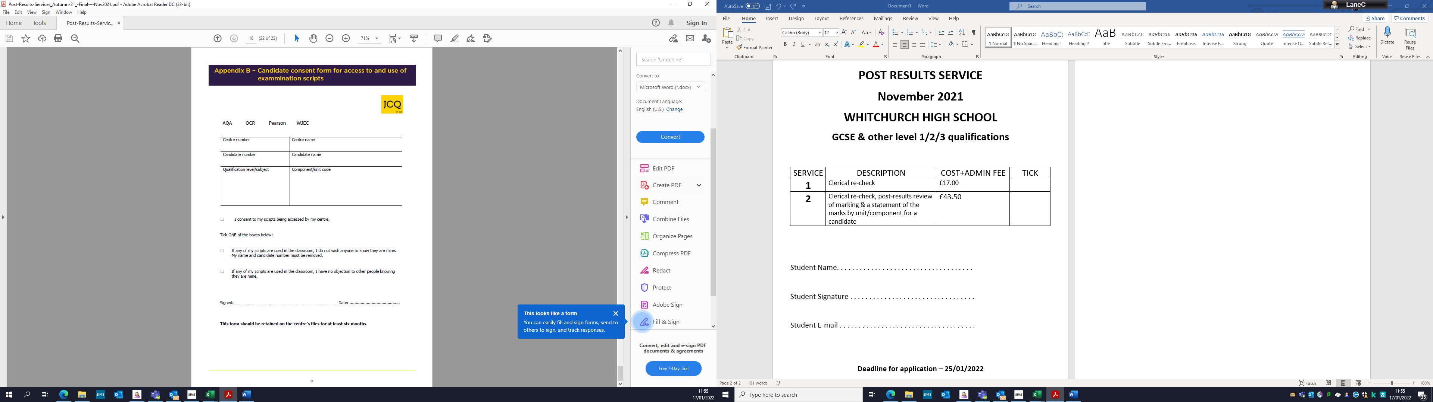
Please note.
